
GENERAL SHOP INSPECTION

SERVICE FACILITY: 26489 Industrial Blvd PHONE: 218-999-5100
Cohasset, MN 55721
CUSTOMER:
SERVICE JOB: | Click or tap here to enter text. |  |  | SERVICE TECHNICIAN
INSPECTION DATE: | 1/19 THRU 1/22 |  |  | NAME: | DH
EQUIPMENT INFORMATION
MANUFACTURER: | GOULDS |  |  | EQ TYPE: |  | SPLIT CASE ROTATING ELEMENT
MODEL: | 3420LDS |  |  | SIZE: |  | 30X30-31
SERIAL NUMBER: | BASED ON |  |  | IMPELLER TRIM: |  | 31-3/8” RIGHT HAND ROTATION
VISUAL INSPECTION NOTES: (BEFORE TEARDOWN)
- THIS ELEMENT HAS PREVIOUSLY BEEN WORKED ON, BUT HAS NO CRANE ENGINEERING TAGS ON IT
TEARDOWN INSPECTION NOTES:
- PRIOR TO DISASSEMBLY .027” OF END FLOAT WAS MEASURED
- THE THRUST END BEARING HOUSING HAD BEEN SLEEVED AND A SHIM (APPROXIMATELY ¼” THICK) HAD BEEN ADDED TO THE HOUSING.
- THE HOUSINGS HAD NO GASKETS, IN PLACE OF GASKETS RTV WAS USED.
- BOTH BEARING HOUSING BORES WERE FOUND TO BE OVERSIZED. THE DRIVE END HOUSING MEASURED 9.846” WHILE THE OPPOSITE DRIVE END MEASURED 9.8542”
- THE RADIAL END HOUSING HAS ONE BOLT HOLE THAT HAS BEEN HELICOILED, WHICH COULD BECOME AN OIL LEAK PATH
- THE VANES ON BOTH SIDES OF THE IMPELLER HAVE SLIGHT WEAR
- THE IMPELLER BORE IS WITHIN TOLERANCE, BUT IS AT THE TOP END
- THE WEAR RINGS ARE WORN. THE CASING RINGS WILL NEED TO BE SKIM CUT TO BE MADE TRUE WHILE NEW IMPELLER RINGS WILL NEED TO BE MADE TO OEM CLEARANCES
- THE SHAFT WAS FOUND TO BE STRAIGHT AND ALL LANDINGS ARE WITHIN TOLERANCES. THERE ARE SOME LIP SEAL GROOVES WORN INTO THE SHAFT THAT CAN BE CHROMED.
- THE SHAFT WAS NDT TESTED AND NO DEFECTS WERE FOUND
RECOMMENDATIONS:
- REPLACE BEARING HOUSINGS, HOUSING COVERS, SLEEVES, SLEEVE NUTS, STUFFING BOX BUSHINGS, BEARINGS, INPRO LABYRINTH SEALS, AND MISC O-RINGS, GASKETS, AND HARDWARE
- MACHINE LIP SEAL AREAS ON SHAFT, SKIM CUT CASING WEAR RINGS, CREATE NEW IMPELLER WEAR RINGS (FLASHED)
- BALANCE ASSEMBLY TO G1.0 SPEC – COTTON BALL FINISH
INSPECTION TIME SPENT: |  | Inspect Hours | ESTIMATED REPAIR TIME NEEDED:

INSPECTION PICTURES
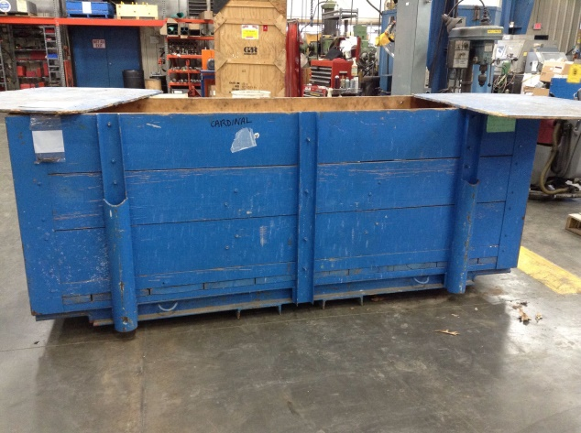 | 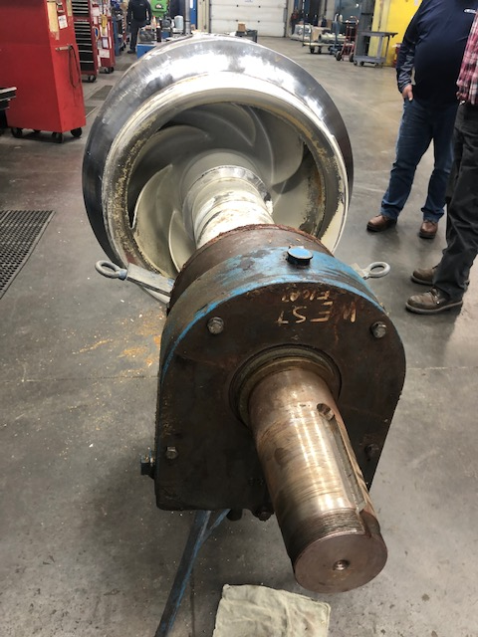
ROTATING ELEMENT WAS RECEIVED IN THE PICTURED CRATE | RADIAL END PRE-INSPECTION PHOTO
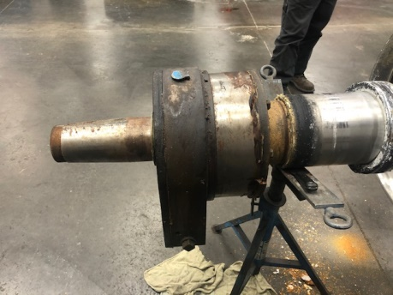 | 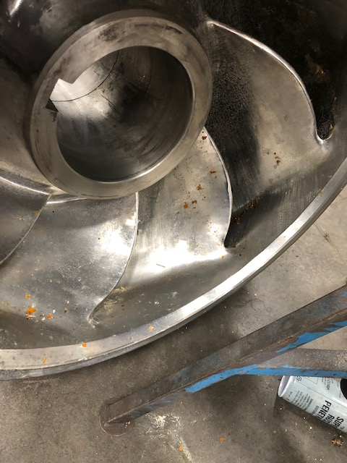
THRUST END PRE-INSPECTION PHOTO | IMPELLER VANE WEAR

INSPECTION PICTURES
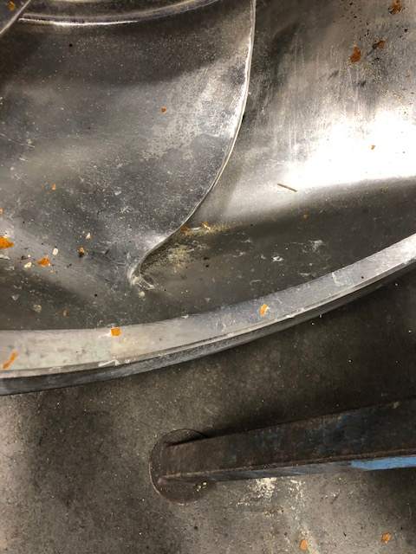 | 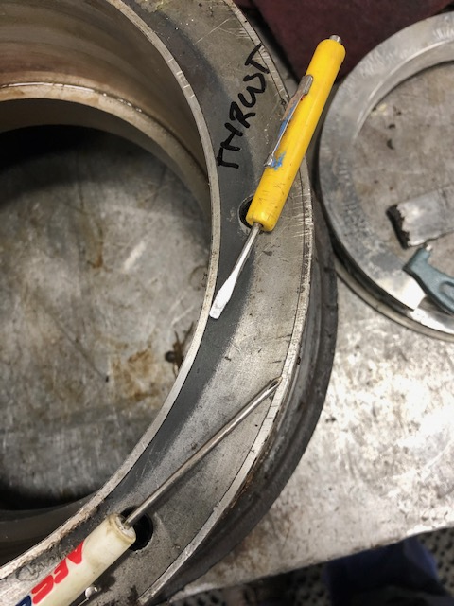
IMPELLER VANE WEAR CONTINUED | SLEEVED BEARING HOUSING
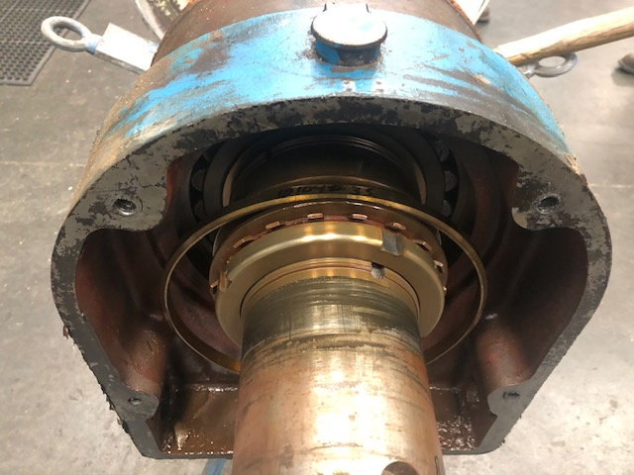 | 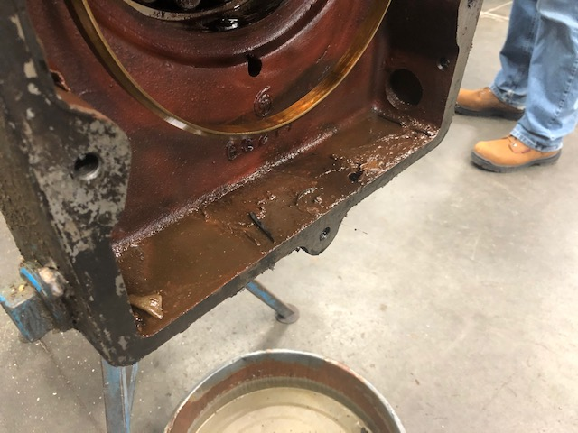
DEBRIS FOUND IN RADIAL BEARING HOUSING | DEBRIS FOUND IN RADIAL BEARING HOUSING CONTINUED

INSPECTION PICTURES
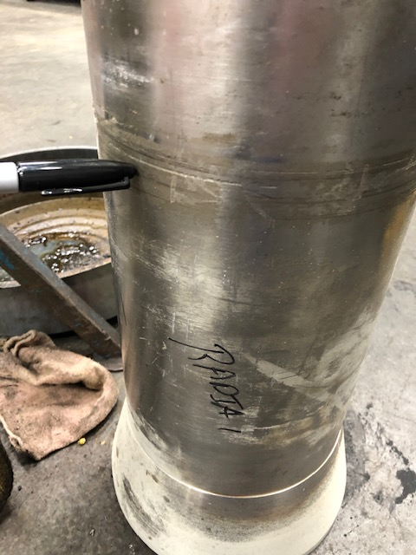 | INTENTIONALLY LEFT BLANK
SHAFT SLEEVE WEAR
INTENTIONALLY LEFT BLANK | INTENTIONALLY LEFT BLANK

